# 

# Project Report Template

**Plugging into the future:An exploration of electricity consumption process**

1.Introduction

1.1 Overview

### **Electricity Consumption**

Global electricity consumption has continued to go up rapidly at a rate faster than energy consumption. Between 1980 and 2013, the world’s annual electricity consumption rose from 7300 TWh to 22,100 TWh. Since the twenty first century, global electricity consumption has seen even faster growth, as evidenced by an average annual increase of 3.4%, 1.2 percentage points higher than average annual growth of energy consumption. Fig. 1.28 shows global electricity consumption during 1980–2013.

The gross electricity consumption per capita in FY2019 was 1,208 kWh.

In 2015-16, electric energy consumption in agriculture was recorded as being the highest (17.89%) worldwide. The per capita electricity consumption is low compared to most other countries despite India having a low electricity tariff.

**1.2 Purpose**

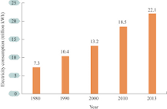

Annual electricity consumption per capita serves as **an important measure of a country's electric power development**. Generally speaking, electricity consumption grows faster when the industrialization process develops quickly and goes down rapidly when industrialization is completed or near completion

Consumption pattern of energy **shows the percentage use of different sources** (solar energy, wind energy, geothermal energy, biogas, and tidal power). The consumption pattern of energy changes over time. Commercial sources of energy: Commercial energy makes up about 65% of the total energy consumed in India

.

**2.Problem definition & Design thinking**

**2.1 Empathy Map**

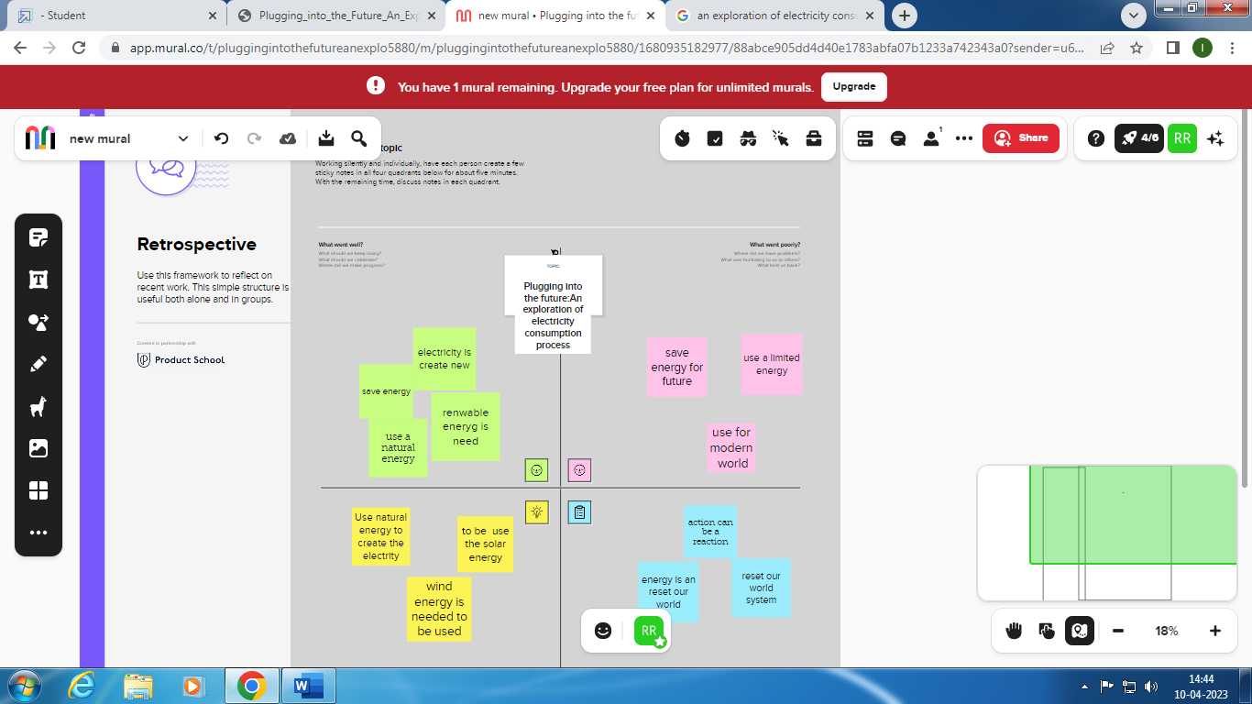

**2.2 Problem in electricity consumption**

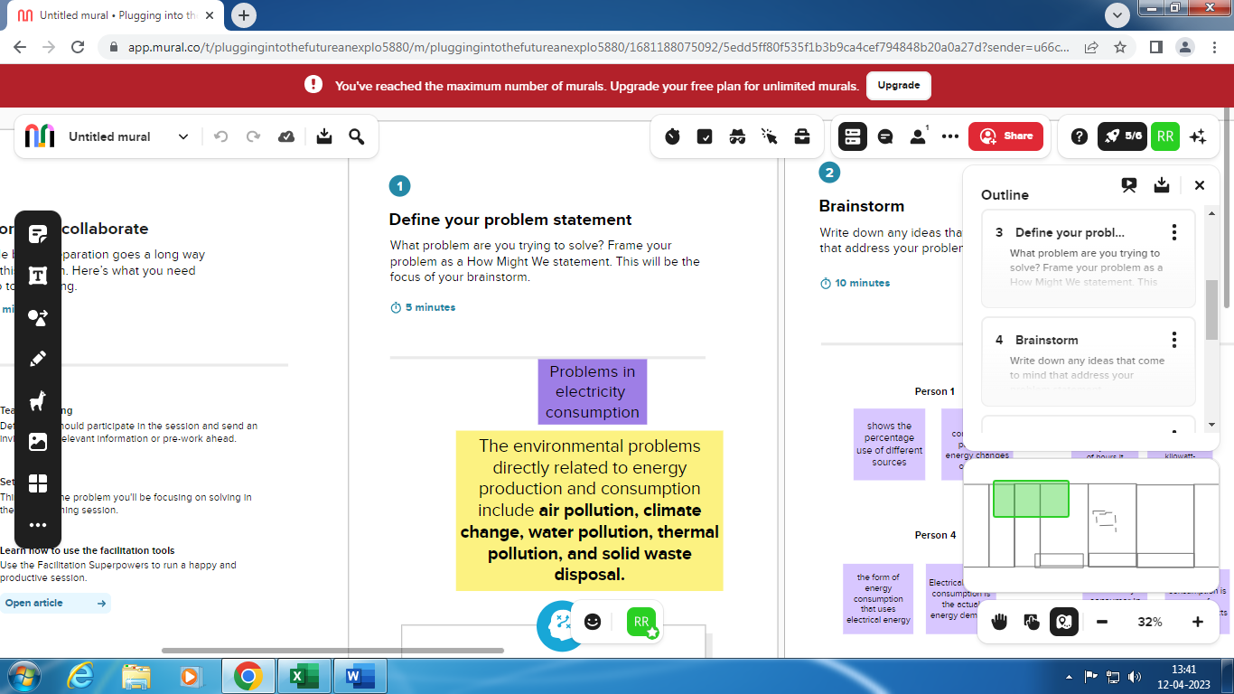

**Brainstorm**

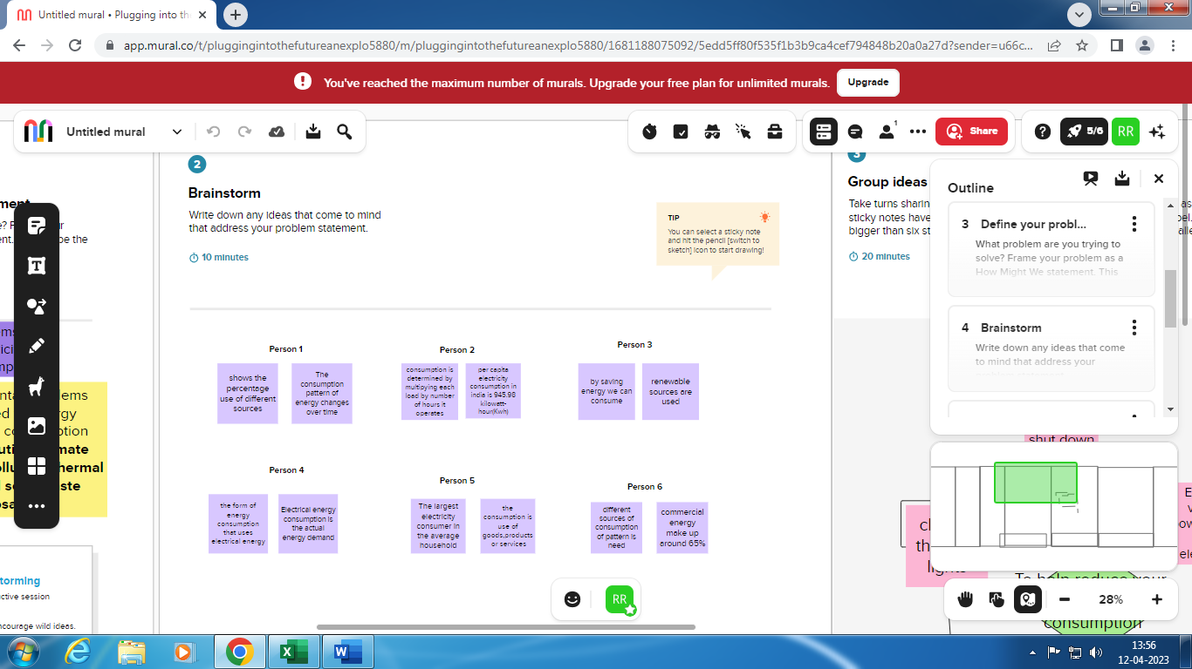

**Group ideas**

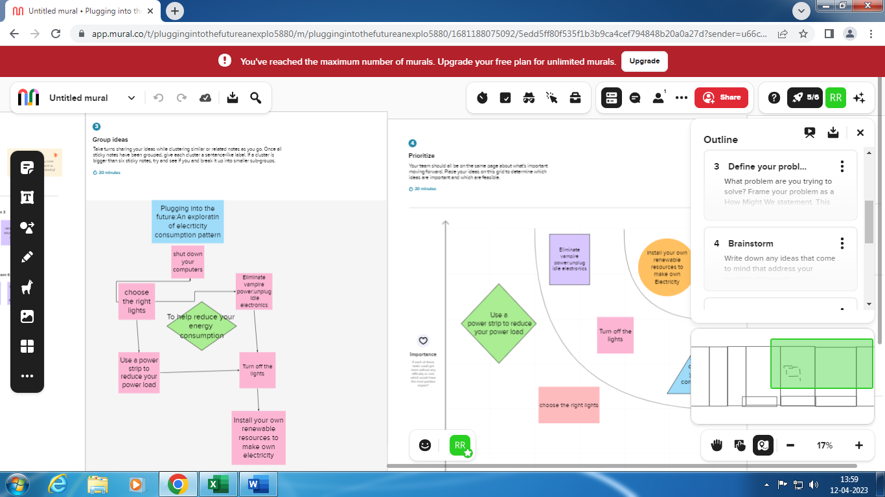

**Prioritization**

**3.RESULT**

**\*Use a smart thermostat.** Smart thermostats can be controlled from an application on your mobile phone or tablet, allowing you to change the temperature when you’re away from the house. They also have multiple sensors that provide a better overall reading of the temperature in your home and heat or cool your home more efficiently than regular thermostats.

**\*Choose energy-efficient appliances.** Switching your electronics to those with an Energy Star label can significantly reduce your energy consumption and therefore your energy bills

.

*Electrical energy consumption is the actual energy demand.So,we have to get rid of it.

*Install your own renewable resources to make your own electricity.

4.Advantages &disadvantages

**Advantages**

**\*** Reducing energy use in your home **saves you money, increases our energy security, and reduces the pollution that is emitted from non-renewable sources of energy**.

**\*The carbon footprint of your property is the total amount of greenhouse gases generated by our actions and is directly linked to the energy that it consumes.lowered carbon footprint.**

**Disadvantage**

*As a consequence, global consumption of electricity is a major contributor to CO2-emissions and climate change

**\***The emission of air pollutants from fossil fuel combustion is the major cause of urban air pollution.

Application

* Incorporate passive solar design concepts into your home, which include using energy-efficient windows.

* Properly insulate and air seal your home.

* Select an energy-efficient heating system that doesn't use electricity.

* Electric water heating -- Purchase an Energy Star heat pump water heater and operate it efficiently.

Conclusion

if we reduce the use of electricity,Reducing energy use in your home **saves you money, increases our energy security, and reduces the pollution that is emitted from non-renewable sources of energy.**

* Properly [**insulate and air seal**](https://www.energy.gov/energysaver/weatherization) your home. Select [**an energy-efficient heating system**](https://www.energy.gov/energysaver/home-heating-systems) that doesn't use electricity.
* [**Electric water heating**](https://www.energy.gov/energysaver/water-heating)-- Purchase an Energy Star heat pump water heater and [**operate it efficiently**](https://www.energy.gov/energysaver/reduce-hot-water-use-energy-savings).
* Reduce your “always-on” appliances.

Future scope

Conservation of electricity is the best way for the future scope

*Energy conservation can be achieved in two different ways that include **reducing the amount of primary energy consumed to supply the useful energy requirement (energy efficiency), and reducing the end point use of nonessential energy**.

* It reduces direct air pollution caused by machinery, vehicles, and power plants.

*  Environmental: Increased efficiency can **lower greenhouse gas (GHG) emissions and other pollutants, as well as decrease water use**. Economic: Improving energy efficiency can lower individual utility bills, create jobs, and help stabilize electricity prices and volatility.